This project was designed to solve 9*9 sudoku. The input of this project is a csv file, e.g.

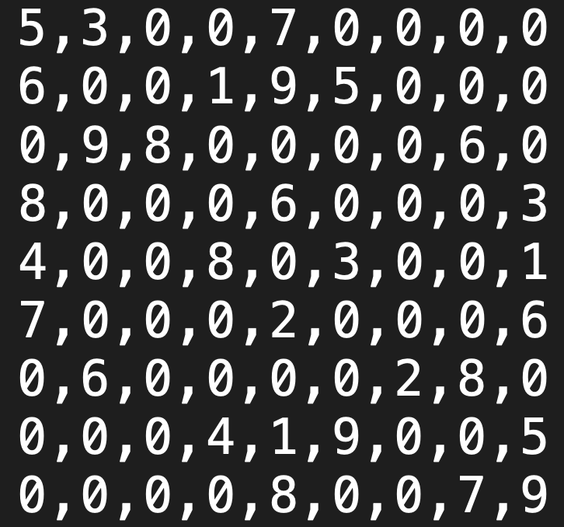

Zeros in the file represent empty positions. The positions are represented by pair<int,int>, with row in the first place, and col in the second.

In this project, a class “chessboard” plays a crucial role. It has three important private variables, AllChess, AllMap, and solvable.

1. First, AllChess is a map, with key pair<int,int> and value int. It records the number (int) on all positions (pair<int,int>).
2. Second, AllMap is also a map, with key pair<int,int> and value vector<int>. It records all possible numbers (vector<int>) on all positions (pair<int,int>). For example, {{2,3}:{1,4,6}} means that it is possible to fill 1, 4, 6 in position {2,3}.
3. Third, solvable represents the solvability of the given chessboard, which is -1 while the chessboard has not been solved, 0 if the chessboard has an unique solution, 1 if chessboard has no solution, and 2 if its too uncertain that the solvability of the chessboard can’t yet be determined (which will initiate initiate_difficult()).

Solving a chessboard typically go through three states.

1. First, the chessboard should be initialized by either a csv file like the one I showed above, or another chessboard. The former case is to set AllChess of chessboard as that in the csv file, and the latter case is to duplicate the input chessboard’s AllChess. After setting up AllChess, AllMap should be set up, too. This work is done by scan(), which scan through all positions and determine the possible numbers that can be filled in each position. Note that if AllChess has two identical numbers in a row/col/block, solvable will be changed to 1 immediately.
2. After initializing chessboard, we now execute solve(), which continue filling numbers into positions. There are two ways to fill a number into a position, either when the position has only one number in AllMap, or the position is the only place to fill in a specific number in its own row/col/block. The former is accomplished by fill_AllChess(), while the latter is accomplished by fill_AllMap(). If at some point, AllChess is completely filled with numbers, then solvable=0; else if AllMap has at least one position that has no possible move, then solvable=1. However, it might be possible that neither fill_AllChess() nor fill_AllMap() can do any further move, while AllMap has more than one possible number for each position. In this case, initiate_difficult() will be executed, and that brings us to the next stage.

After stage 2, some easy sudoku may have already been solved, the program will print out the result and halt. In addition, some sudoku has no solution, and if program finds it unsolvable, it will halt as well. In other words, stage 3 will not be executed in these cases. Here are some examples.

Solvable

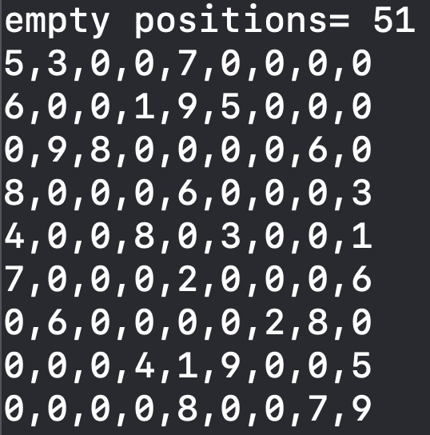 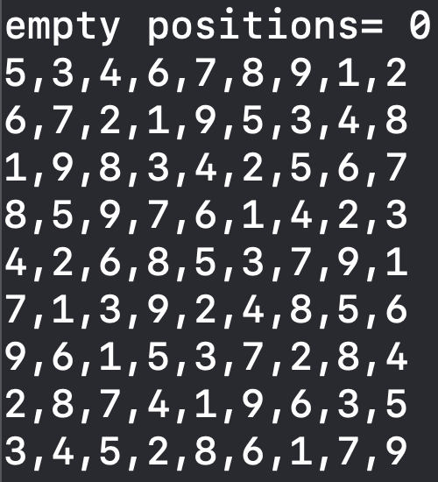

No solution

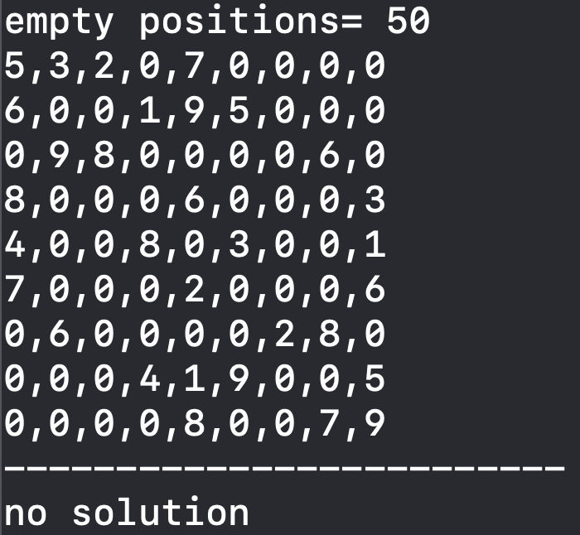

1. Sometimes, the sudoku is too difficult, and initiate_difficult() will be executed. First, the positions with least lengths in AllMap will be selected. The number of selected positions is determined by constexpr int difficulty. After that, all possible ways to fill in those positions are tried. For example, if position {2,3}, {4,5} are selected, each of them has AllMap values {1,3}, {2,3,7}, respectively, then {1,2}, {1,3}, {1,7}, {3,2}, {3,3}, {3,7} will all be tried. After trying all these combinations, I can decide whether there is a solution. Furthermore, if there exist two or more solutions, I can find all of them.

Examples that requires stage 3:

Only 1 solution:

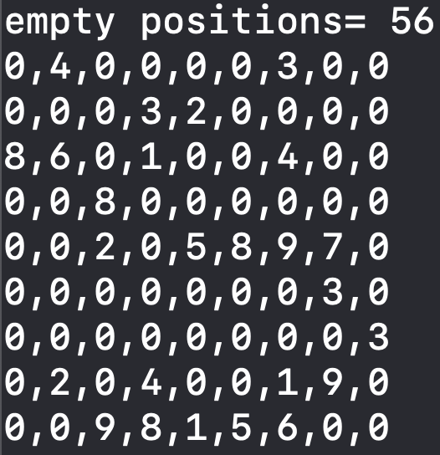 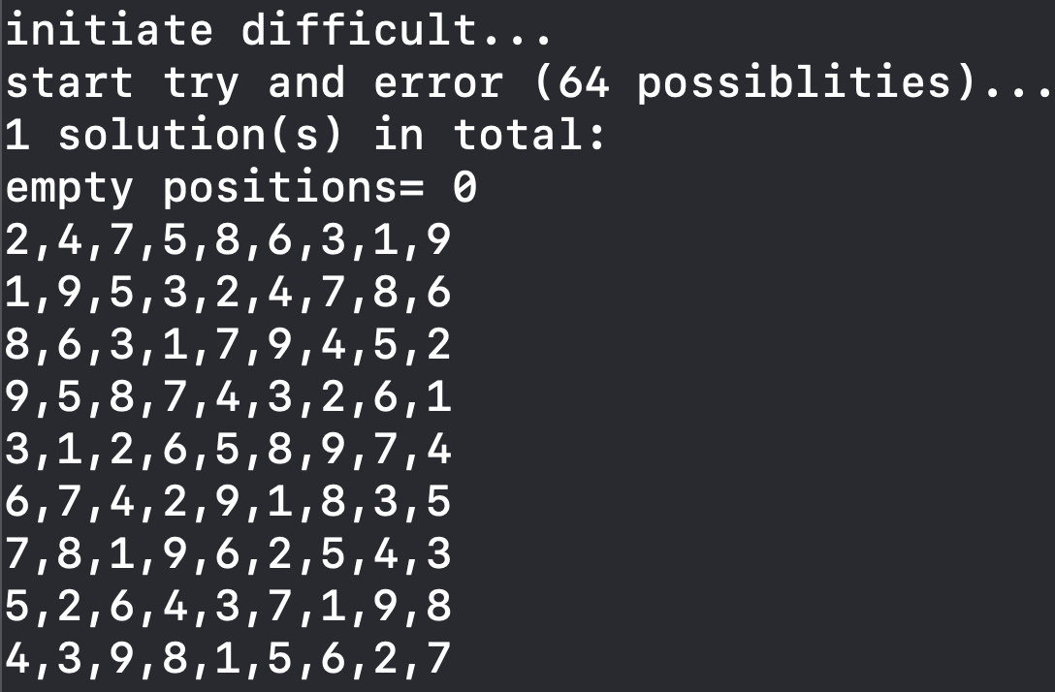

Multiple solutions:

 

 

No solution:

 